***Policy Disruption: The challenges of implementing change in the electricity industry.***

***Introduction:***

In 2009, after the planned phase out of coal in Ontario, the Ontario government was facing a new challenge of growing energy demand and ageing infrastructure (C.Stokes, 2012). Motivated to incorporate new renewable sources of energy into the electricity mix, the government of Ontario passed the Green Energy Act in 2009. The intentions of the government were stated to highlight Ontario’s commitment to renewable energy projects and to promote a green economy (Ministry of Energy, 2009). Since the passing of the Green Energy Act, the Ontario government has introduced several programs to incentivise the adoption of renewable energy including Feed in Tariff (FIT), microFIT, Smartgrid fund and energy storage procurement programs. With a common objective of helping to integrate renewable sources of energy, these programs sought to incentivize the adoption of new technologies within an existing, established industry without investing in modernization of the existing infrastructure or reviewing the impacts of those policies on existing stakeholders. The result of implementing policy without addressing its impact on entrenched systems is increasingly adding stress on both the electricity grid as well as the stakeholders that are crucial to its operation (Christina E. Hoicka, 2011).

As renewable generation technologies begin to be added to the electricity grid, the current policy implementation tools impede their effective integration within the utility grid as evidenced by the poor integration of wind electricity in Ontario (Ontario Society of Professional Engineers and Professional Engineers of Ontario, 2013). One key contributor to this condition is the prescriptive manner in which policy instruments are designed. Policy tools like FIT are designed to achieve specific targets mandated to measure the amount of renewable generation on the electric grid, without consideration to how the electricity is being consumed. A look at the recent FIT review highlights in its accomplishments sections that the FIT program has “Contracted 4,600 megawatts (MW) in addition to 2,500 MW through the Green Energy Investment Agreement (GEIA)—expected to produce enough electricity each year to power 1.8 million homes;” (Ministry of Energy, 2012). While a key metric for the success of the FIT program can be the amount of electricity produced from renewable generation or contracted to be produced through renewable sources, another key metric should also include how much of that electricity is actually integrated into the system. Without considering the level of renewable energy successfully integrated within the system a false sense of accomplishment is created. While the IESO can claim that 8% of electricity installed in Ontario is wind (IESO a, 2016), arguments have been raised about the value of this electricity if it cannot be used effectively as it is not efficiently integrated within the existing grid (Ontario Society of Professional Engineers and Professional Engineers of Ontario, 2013). Additionally, the continued use of FIT to add more renewables in the Ontario electricity grid should be measured against the need for more electricity generation in Ontario. With a forecasted oversupply of electricity expected till the year 2032, one questions the need for bringing on more renewable generation without effectively integrating the existing supply (Office of the Auditor General of Ontario, 2015).

Effective policy implementation needs to consider the impact of decisions on individual stakeholders (Pal, 2014). As the current electric grid undergoes “greening”, the number of stakeholders impacted adds additional complexity to the challenges faced by policy makers. A key example of this conflict can be seen through the integration of FIT projects. While the Provincial Government incentivizes the development of renewable projects, the management of these installations is largely left in the purview of the Local Distribution Companies LDCs. LDCs that have traditionally been responsible for managing the distribution network are now facing new challenges as they take on the role of managing generation assets, a role traditionally filled by transmission companies (Voisine, 2016). Transmission companies are typically responsible for bringing electricity generated from large centralized generation locations to the LDCs where it is then distributed to the consumer through the LDC distribution network. As renewable generation assets are increasingly located within the jurisdictions of the LDCs, this emerging role is creating pressure on the LDCs who are compensated mainly for the amount of electricity that is sold through them. Successful implementation of policies aimed at creating a greener electric grid will need to address the emerging issues faced by stakeholders that are critical in maintaining a functioning electric grid.

The following paper analyzes the impact that green policy instruments are having on existing electricity infrastructure and key stakeholders. It highlights the emerging conflicts that are taking form through the integration of new technology without matching efforts to strategically redefine new industry standards and incentives.

***Existing industry stakeholders and roles:***

The current electricity system in Ontario can be divided into the following categories (IESO, 2014):

* Electricity generators (Ontario Power Generation, OPG, and Independent generators under the control of the Independent Electricity System Operator, IESO)
* Electricity Transmission- Hydro One
* Electricity Distribution- Local Distribution Companies like Ottawa Hydro
* Consumers

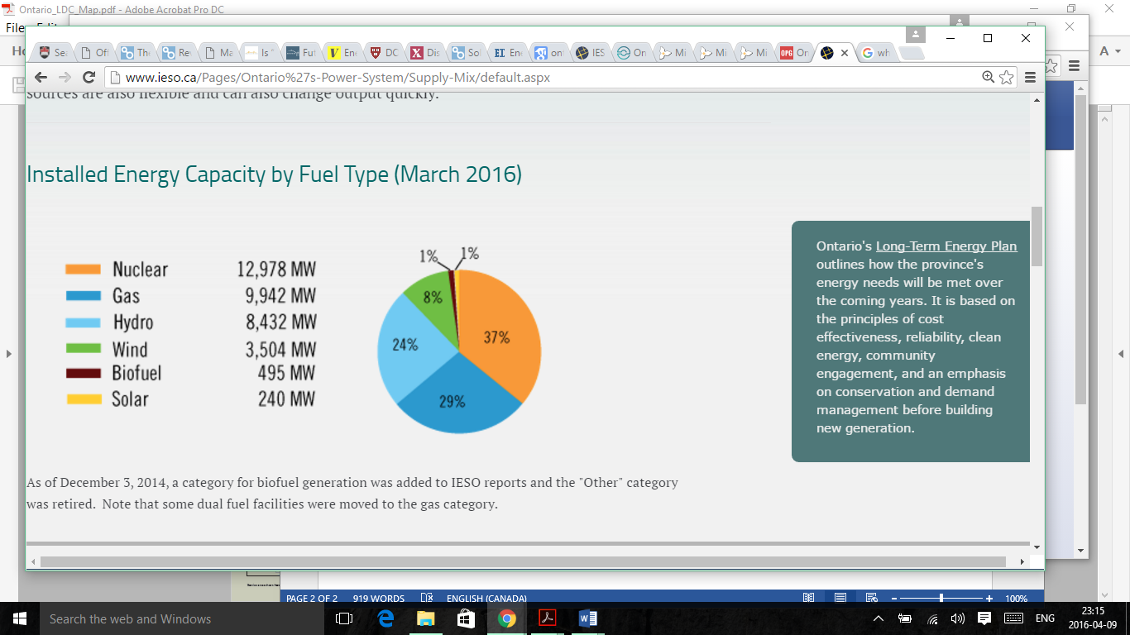The Ontario grid is largely centralized with much of the planning concentrated within the IESO. The IESO is a non-profit regulating origination that is regulated through the Ontario Energy Board, OEB. The IESO administers and governs the rules of the electricity market in Ontario. It manages the overall supply and demand of the Ontario market and overseas the wholesale price of electricity and plans the provinces short and long term electricity needs (IESO b, 2016). The IESO is also responsible for implementing the policies mandated by the Ontario government and Ministry of energy. The OPG along with independent electricity suppliers sell electricity to the IESO. While the IESO was created to help create more competition in the supplier market, the OPG remains the dominant provider of electricity into the system providing over half the electricity in the province (OPG a, 2016). The OPG along with other nuclear facilities provides over 30% of the installed energy in Ontario is Nuclear, which is often referred to as base load power (IESO a, 2016). The OPG supplies almost half the electricity used by the province. Independent suppliers who provide electricity to the IESO come from a varying mix of fuel sources including hydro, wind, solar and biofuel. Figure 1 highlights the mix of fuels in Ontario’s installed capacity.

Figure Ontario Energy Mix by Installed Capacity (IESO a, 2016)

Electricity is produced by the generators and sold to the province through the IESO at market rates or rates determined by existing contracts such as FIT. The OPG determines the rates paid for the Nuclear power in Ontario (OPG a, 2016). The IESO then plans where the power goes and distributes it to the LDCs who then transmit it to the customers. The LDCs are paid for the amount of electricity that is sold to their customers directly (Voisine, 2016).

The current centralized structure of the electricity market in Ontario has been a corner stone of electricity markets where electricity is centrally produced and then pushed through the grid to an end consumer (Keay, 2016). However, a key complication arises as electricity generation becomes de-centralized through independent markets, similar to Ontario, and programs like FIT.

***Successful program implementation, unintended market impacts***

The FIT program in Ontario is designed to bring more renewable generation into the electricity mix. The Ontario Ministry of Energy defines renewable generation as “Energy derived from natural resources including solar PV, wind, waterpower, and bio-energy (biogas, landfill gas, and biomass). These resources are naturally replenished, so they are described as renewable” (Ontario Ministry of Energy, 2016). Given the definition of “renewable generation” used by FIT rules, the impact would be that FIT projects would produce electricity when the renewable resource, like solar or wind, is available and sell it to the IESO when they are able to produce electricity, at contracted rates determined by FIT contracts without regard for the amount of demand in the market at the given time. Managing the demand and supply would fall to the IESO. An example of contracts that fall within this category would be wind energy contracts under FIT which reflect 8% of the installed power in Ontario. Wind power is largely produced during the evenings, a time when overall demand of electricity is low. IESO is contracted to purchase all wind electricity when it is produced, thus wind power is bought even when demand is low. Additionally, as highlighted Ontario’s base power has a largely nuclear contribution. The IESO enters into contracts with nuclear power plants to purchase a given amount of power on a wholesale base, additionally nuclear power cannot easily be turned off (Office of the Auditor General of Ontario, 2015). This creates a unique situation in Ontario where the IESO is purchasing power from both nuclear plants as well as wind energy at a time of day when the demand is low. The overall impact on the province is that it effectively pays neighbouring jurisdictions to get rid of the excess power that is generated (Office of the Auditor General of Ontario, 2015). Thus, while the province of Ontario has an installed over share of 8% wind, that power cannot be effectively integrated within the system (Ontario Society of Professional Engineers and Professional Engineers of Ontario, 2013).

While the FIT program can be measured to be a success due to the amount of installed capacity, the overall objective of the policy was to ensure a greener electric grid and integration of renewable sources in the electricity supply. One key question raised from the FIT policy rules comes from the exclusion of behind the meter projects (IESO, 2015). The meter being the point of the electricity exchange where the electricity transfers from the control and jurisdiction of the producer to the IESO/ LDC. According to the FIT rules, all the electricity generated behind the meter by the generator must be sold directly to the IESO. Once the electricity crosses the meter it enters the control of the IESO who can then allocate it as it sees fit. If a renewable electricity generator stored the electricity while it was being generated and sold it to the IESO at another time, this would be classified as a ‘behind the meter project’ and would be disqualified from the project. Additionally if the generation facility used the electricity it was producing, effectively lowering its own demand, before selling it to the IESO this would also classify as a ‘behind the meter project’ and would not qualify for the FIT program. Given the intermittent nature of wind the IESO is further challenged in meeting its long term planning objectives as it cannot plan to reduce the electricity from other sources in lieu of wind without being certain that the supply will be available, this results in the IESO planning for both wind and a backup source of electricity, thus overbuilding the capacity of the grid.

One solution to the inherent inefficiency created by FIT could have been to integrate energy storage technologies alongside FIT installations. The IESO could create contracts that would ensure the quality and time of electricity supplied by FIT suppliers and incentivize them to make the existing grid more efficient through the use of energy storage. Recognizing the need for energy storage, the IESO procured 50 MW of energy storage technologies but used a second program offering rather than modifying the FIT rules (IESO c, 2016). These projects are planned to showcase the potential of energy storage technologies at the utility scale. A closer look at the IESO energy storage procurement plan reveals a program designed to showcase the breadth of services that energy storage technologies can provide to the grid. Viewed in insolation the program can be measured to be a success if it showcases how storage technologies can provide regulation services (phase 1), how energy storage operators can provide electricity arbitrage value (phase 2) and grid level storage capability (phase 2) (IESO d, 2016). While these pilot projects provide some value to the overall grid, its contribution to the overall objective of creating a greener grid are not clear. In isolation the energy storage procurement appears to have been implemented successfully. The goals of the program are clearly highlighted, the success metrics are defined (Pal, 2014) however it is important to question how either the FIT program or the energy storage procurement contribute to the overall intent of the green energy act to create a green energy future.

In assessing the policy implementation for the Green Energy Act, one key question raised is how success is being measured. A closer look at the Ontario electricity markets lends some interesting insight. Figure 2 highlights the amount of electricity being traded in Ontario. While Ontario is revealed to be a net exporter of electricity, it continues to also import electricity. Additionally in a recent report by the Auditor General it is revealed the 47% of electricity being exported from Ontario is the result of excess capacity (Office of the Auditor General of Ontario, 2015). Exports related to excess capacity are “dumped”- Ontario pays other jurisdictions to get rid of this capacity or turns off generators like wind while continuing to pay for the energy that could be produced. The combination of planning for a secure grid, while promoting renewable energy programs in silos has created an inefficient electricity market.

***Unintended impacts of program implementation on stakeholders:***

Figure 2 Ontario electricity exchange (Data from IESO, 2016)

While electricity generation has been increasingly de-centralized in Ontario, the impact of programs like FIT on LDCs and municipalities is unique. Figure 3 illustrates how centralized markets have been traditionally structured.

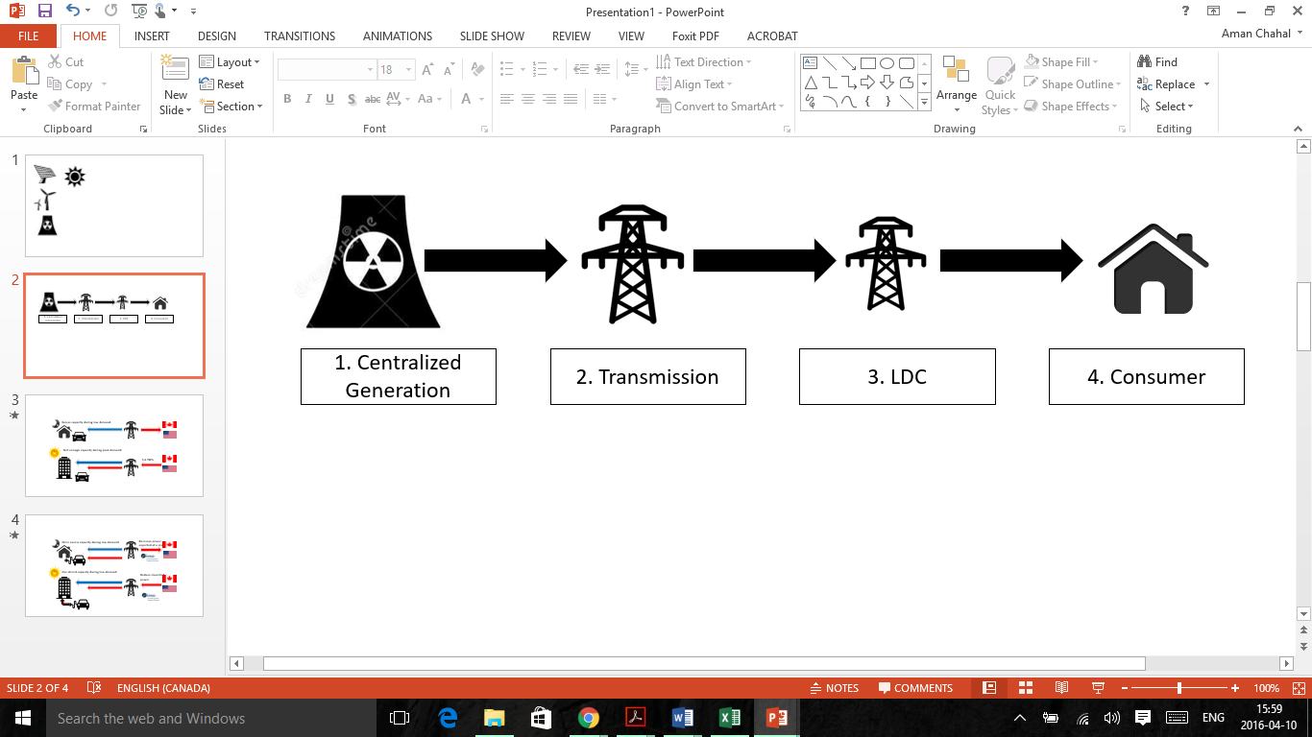

Figure 4

Figure 3 Traditional centralized energy structure

Electricity markets have been designed to move electricity from large generators to customers in one direction. The infrastructure has been designed to ensure the reliability of electricity to the consumer and incentives have been designed to ensure quality measures are maintained throughout the system. One key example is the incentives and revenue structure for the LDC. The role of the LDC is to act as a pathway for electricity generated to reach the customers in its jurisdictions. The LDC has a fixes and variable source of revenue for the services it provides. The variable source of revenue for the LDC comes from the amount of electricity that is sold through its transmission grid. While the LDC has some fixed revenue sources, the bulk of its revenue is the cost per KWh that is sold to its customers. Additionally the LDC is responsible for maintaining the quality of the electricity that is supplied to the customer and pay for all associated costs that are incurred to provide this service (Ontario Energy Board, 2015). In a market structure where all electricity flows in one direction and each stakeholder has a defined role to play in the supply chain, such incentive structures are successful. However a look at how the electricity markets have changed since the integration of renewable generation is key in understanding the conflicts taking shape in a decentralized energy system.

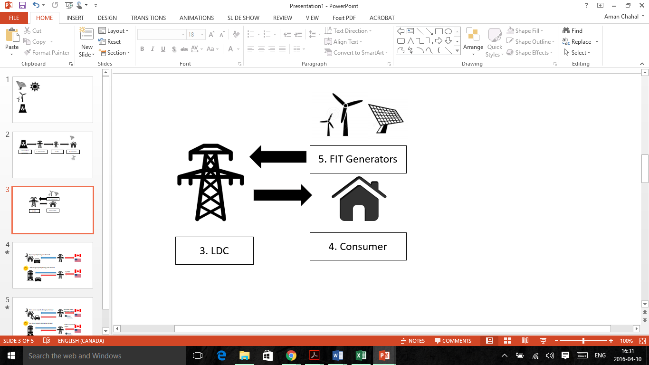As new FIT generators participate in the electricity market, increasingly these distributed generation (DG) generators are located closer to the consumers where the load is, and thereby within the jurisdictions of the LDC (Kiesling, 2015). The technical impacts of having generation sources, especially renewable generation sources on the distribution grid relate to their integration. The LDC must develop mechanisms for 2 way sharing on their grid, which requires upgrading specific technologies like transformers and adapting to new controls. Additionally, renewable generation sources like solar have fluctuating voltage outputs depending on the quality of the source and time of day when the sun is shining without cloud cover. The LDC is responsible for ensuring the integrity of the grid, therefore they are required to upgrade their systems to adapt to react to changes in electricity input from the new generation sources. These new upgrades are paid for by the LDC itself, without being equipped by the province with additional sources of revenue the LDC either pays for them itself or passes the cost on to the customer. Many LDCs are seeing their profits erode as their role in the electricity supply chain is increasingly growing (Kiesling, 2015). Operating an increasingly de-centralized grid with the incentive structures of a centralized regime is creating barriers for stakeholder and preventing the grid from operating efficiently.

Figure 4 Changing market conditions for LDC

One possible alternative to supplying all the electricity generated from the FIT contracts to the distribution grid is to have local communities use their electricity and then share with other communities that may be in need, creating a network of microgrids that alleviate the pressure on the LDC and centralized grid. These installations would classify as “behind the meter” and would no longer be qualified for their FIT contracts.

***What is successful implementation?***

While Ontario set out to create a greener economy through investments in clean energy, it is important to ask certain key questions about how the government would measure success and what their vision of a green economy was. In a province with a large nuclear energy base, supplemented with hydro-electricity how much “renewable energy” would mandate a successful policy? Nuclear and hydroelectricity produce little Greenhouse Gas (GHG) emissions. If Ontario wanted to replace its nuclear power base with renewable energy sources, then it is critical to examine how the understanding of renewable energy in Ontario has let to successful programs failing to achieve their objectives. There are 3 nuclear power generation plants in Ontario Bruce, Pickering and Darlington. With a combined installed capacity of over 12 GW, nuclear power contributes a significant amount of electricity to the Ontario grid. While nuclear power has traditionally provided a stable source of low carbon energy into the Ontario grid, all three reactors are nearing their end of life within the next 10 years. The Pickering plant is expected to expire in 2018 (Canadian Nuclear Safety Commision a, 2016), the Bruce station licence is expected to expire in 2020 (Canada Nuclear Safety Commision b, 2016) and Darlington is expected to expire in 2025 (Canada Nuclear Safety Commision c, 2016). The Darlington station has been scheduled to undergo refurbishment at a cost of $12.8 Billion to the province with expected completion in 2026 (OPG b, 2016). Thus while Darlington may continue to operate beyond 2025 the province of Ontario will be looking to replace 9.3 GW of electricity of base power within the next few years. Renewable energy appears to be an ideal possibility to fill the vacuum that will be left behind by nuclear power. The IESO push to reduce consumption through conservation programs along-side the addition of renewable energy have been some key programs to address the issue. However, without key changes in how the success of these programs is measured the progress remains limited and the potential for renewable energy is increasingly becoming an unrealized dream.

***Integrating renewables: Not all energy is created equal***

Given the changing conditions in the Ontario electricity markets with the decommissioning of nuclear power, Ontario can still capitalize on using renewable energy. The key to successful integration of renewable electricity in Ontario is largely dependent on how policy instruments define the term “renewable energy” and the considering the impact of using such narrow definitions of the terms in policy instruments. The FIT program classifies renewable energy as, “Energy derived from natural resources including solar PV, wind, waterpower, and bio-energy (biogas, landfill gas, and biomass). These resources are naturally replenished, so they are described as renewable” (Ontario Ministry of Energy, 2016). The explicit definition of renewable generation technologies along with the criteria that any FIT installation must not exceed 2 MW (IESO, 2015) and cannot have any ‘behind the meter’ installations, will not be able to replace nuclear energy. If the objective is to replace nuclear energy then the type of generation source that is installed in its place is not an accurate measure of the success of any program. Rather the *use* of the energy would be a better characterization of success. A more accurate way to consider would be to measure how much energy from renewable sources can effectively used in lieu of nuclear energy. By considering the end use of the electricity rather than the source of the electricity a more comprehensive understanding of integration can be developed.

Take for example the 8% of installed wind capacity in Ontario. If 8% of nuclear energy is to be replaced by 8% of wind energy then we need to consider what kind of system needs to be designed to effectively provide the same quality electricity. The first key criteria would be to ensure that the electricity coming from wind would have the same quality (voltage) as nuclear energy without adding additional constraints onto the system. This could be achieved through technical measures set up at the generation site to ensure the quality of the power. The second key notable criteria is that nuclear energy is base load; it is predictable, easy to plan, cheap and reliable. Wind energy in isolation is unpredictable and therefore difficult to plan but cheap when it is being generated. If the IESO’s objective is effective integration of wind as a baseload energy, a natural solution would be to integrate some form of storage alongside wind power. Adding a combined storage and renewable generation plant can replace nuclear power, however in isolation wind power cannot be effectively integrated on the grid to replace nuclear power (Paul Denholm, 2010). Hybrid renewable plants that integrate multiple generation sources along-side storage can also help to better integrate renewable generation sources (Christina E. Hoicka, 2011). These installations would vary the geographic locations where renewable generators are placed and have a variation of sources that can be alternated to ensure that there is less operational disruption caused by the variability in the electricity produced.

Another key tool in integrating renewable technologies can be as simple as the manner in which electricity communities are structured though microgrids. Microgrids are a group of interconnected loads and energy resources within an electrical boundary that act as a single controllable unit with respect to the grid, these microgrids can be operated in islanded mode (independently from the grid) or in non-islanded mode, connected to the grid (MaRS, 2015). As electric grids become increasingly de-centralized and generation is embedded closer to the consumer, microgrid communities can be leveraged to use locally produced energy though these resources and then selling the excess back to the grid. The overall impact of organizing electricity in such a manner would be to reduce the load on the distribution network as electricity would travel shorter distances, reduce the load on centralized electricity planning as microgrid communities could integrate several technologies like storage to ensure consistent supply of their needs and defer any capital costs that would need to be incurred by the province to build new power plants to replace aging infrastructure. The IESO along with many local Ontario stakeholders recognize the value of microgrids and have been active contributors to this dialogue (MaRS, 2015). However the integration of microgrids would inherently challenge the existing policies that have been implemented by the province to encourage renewable generation. While microgrids are gaining favor internationally as a key tool in renewable integration, deploying microgrids effectively would require the province to address gaps in stakeholder incentives and restructure existing policy instruments.

Technology is fast evolving and revealing gaps in the policy instruments used to promote integration. These evolutions can be seen in number of programs that have been created by the IESO. The original intention to incorporate renewable generation was incentivized by creating FIT. Subsequently home owners and smaller businesses wanted to participate in these programs and a microFIT program was designed as a separate program. Some homeowners wanted to use the electricity they were producing themselves and so net metering was introduced. The province recognized the value of smart grid technologies and instituted smart grid reforms. The value of energy storage was increasingly coming into focus and thus the province issued 50 MW of energy storage programs on the grid. All these programs have been supplemented by careful and serous conservation measures that have also been a large part of the IESO programs. The breath of programs offered in Ontario highlight that the province recognizes the need for renewable generation. As new technologies emerge programs are being created to incentivise them. However these policies are created in isolation, they are not strategically connected and this division is revealed when the overall effectiveness of the provinces electricity market is measured.

Creating a cohesive strategy to ensure that electricity markets operate effectively and satisfy the intended goals of the policy requires an examination of how old paradigms and roles of stakeholders are being challenged. New market designs are needed to incentivize the overall objective of the policy and the vision for Ontario’s electricity future. LDC’s that are seeing a new emerging role on the front line of the transmission grid need to have new revenue models that can help them promote the adoption of new technologies and ensure the integrity of the existing grid. Additionally, as renewable technologies can be combined with themselves and be reorganised in new structures, policy instruments need to be redesigned to consider the end objectives rather than promote singular goals. Designing programs to promote development of generation, while separately promoting storage and having different measure for transportation and integration are increasingly coming in conflict with the pace of technology change. Technologies are emerging that enable new forms of electricity, these technologies are emerging faster than policy programs can be created. The increasing adoption of electric vehicles is opening new potential policies for adapting the grid to enable Vehicle to Grid electricity sharing and opening more opportunities for peak shaving. Successful integration of these new emerging paradigms requires a systems thinking approach and a more integrated form of creating policy. These barriers are increasingly being felt in other jurisdictions where renewable technologies have already becoming a larger part of the grid such as Germany (Keay, 2016). Lessons in market design and restructuring can be learned and adopted from these jurisdictions but as new technologies energy, innovative policy tools are needed to ensure that policy tools are not standing in the path of technological progress.

***Conclusion:***

In 2014, the last coal plant was decommissioned in Ontario, completing an initiative that began almost a decade earlier (C.Stokes, 2012). The phase out of coal presented a unique window of opportunity for Ontario to begin to put in place the policy infrastructure needed to create a green economy. In the time since the Green Energy Act was passed, several programs were created to promote the government’s goals and to incentivize adoption of renewable generation technologies. When measured in isolation, under the parameters set forth for each individual program, Ontario has made considerable progress with over 10% of installed energy in Ontario coming from renewable sources, the procurement of over 50MW of energy storage and numerous contracts granted for microFIT programs. The report card for each individual program positions Ontario as a leading province in developing a green electric grid. Unfortunately a closer look at the effectiveness of these policies in combination reveals a patchwork of initiatives with few strategic collaborations between them. The programs have been created and managed by a legacy of centralized control with little collaboration between impacted stakeholders. Opportunities have been missed when gaps were recognized, such as the separation between energy storage and FIT. As new technologies continue to emerge a new opportunity is taking form for the province. Creating programs with a connecting strategic objective and measuring success through collaborative measures the province can simplify the program landscape while promoting innovation. Alternatively, by continuing to create programs that measure success without any measure of strategic collaboration the province will continue to have successful programs that ultimately fail to achieve meaningful change.

# References

C.Stokes, L. (2012). The politicsofrenewableenergypolicies:Thecaseoffeed-intariffs. *Energy Policy*, 490-500.

Canada Nuclear Safety Commision. (2016, 04 08). *Bruce A and B Nuclear Generating Stations*. Retrieved from Nuclear Stations: https://www.cnsc-ccsn.gc.ca/eng/reactors/power-plants/nuclear-facilities/bruce-nuclear-generating-station/index.cfm

Canada Nuclear Safety Commision. (2016, 04 08). *Darlington Nuclear Generating Station*. Retrieved from Nuclear Facilities: https://www.cnsc-ccsn.gc.ca/eng/reactors/power-plants/nuclear-facilities/darlington-nuclear-generating-station/index.cfm

Canadian Nuclear Safety Commision. (2016, 04 08). *Pickering Nuclear Generating Station*. Retrieved from Nuclear Facilities: https://www.cnsc-ccsn.gc.ca/eng/reactors/power-plants/nuclear-facilities/pickering-nuclear-generating-station/index.cfm

Christina E. Hoicka, I. H. (2011). Solar and wind resource complementarity: Advancing options for renewable. *Renewable Energy*, 97-107.

IESO. (2014, 01). *Overview of IESO Administered Markets.* Toronto: IESO. Retrieved from IESO.

IESO. (2015). *Feed in Tariff Program FIT Rules.* Toronto: IESO.

IESO. (2016, 04 08). *About Us*. Retrieved from About the ieso: http://www.ieso.ca/Pages/About-the-IESO/default.aspx

IESO. (2016, 01 08). *Energy Storage Procurement*. Retrieved from IESO: http://www.ieso.ca/Pages/Participate/Energy-Storage-Procurement/default.aspx

IESO. (2016). *IESO Report: Energy Storage.* Toronto: IESO.

IESO. (2016, 04 09). *Imports and Exports*. Retrieved from IESO: http://www.ieso.ca/Pages/Media/Imports-and-Exports.aspx

IESO. (2016, 04 08). *Ontario Energy Supply Mix*. Retrieved from IESO: http://www.ieso.ca/Pages/Ontario%27s-Power-System/Supply-Mix/default.aspx

Keay, M. (2016). *Electricity markets are broken- can they be fixed.* Oxford Institute of Energy Studies.

Kiesling, L. (2015). *Implications of Smart Grid Innovation for Organizational Models in Electricity.* Wiley Handbook of Smart Grid Development.

MaRS. (2015). *Microgrids Today.* Toronto: MaRS.

Ministry of Energy. (2009). *Green Energy and Green Economy Act, 2009 , S.O. 2009, c. 12 - Bill 150.* Toronto: Government of Ontario.

Ministry of Energy. (2012). *Ontario Feed in Tariff Program Two-Year Review.* Toronto: Ontario Government.

Office of the Auditor General of Ontario. (2015). *Annual Report.* Totonto: Auditor General of Ontario.

Ontario Energy Board. (2015). *Distribution System Code.* 2015: Ontario Energy Board.

Ontario Ministry of Energy. (2016, 04 08). *Glossery*. Retrieved from Ontario Ministry of Energy: http://www.energy.gov.on.ca/en/fit-and-microfit-program/2-year-fit-review/glossary/

Ontario Society of Professional Engineers and Professional Engineers of Ontario. (2013). *Limits to Renewable Energy.* Toronto: Ontario Society of Professional Engineers.

OPG. (2016, 04 08). *About OPG*. Retrieved from OPG: http://www.opg.com/about/Pages/about.aspx

OPG. (2016, 04 08). *Darlington Refurbishment*. Retrieved from OPG: http://www.opg.com/generating-power/nuclear/stations/darlington-nuclear/darlington-refurbishment/Pages/default.aspx

Pal, L. A. (2014). Policy Implementation. In L. A. Pal, *Beyond Policy Analysis* (pp. 185-220). Toronto: Nelson Educaiton Ltd.

Paul Denholm, E. A. (2010). *The Role of Energy Storage with Renewable Electricity Integration.* Golden, Colarado: NREL.

Voisine, L. (2016, 03 08). Grid Technology Manager. (M. Q. Aman Chahal, Interviewer)